**Overall View**

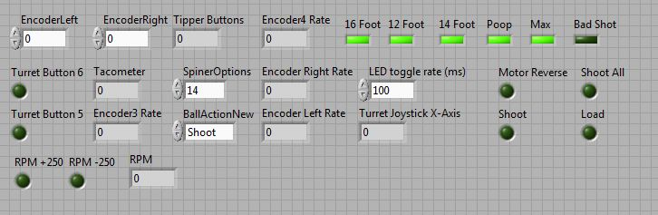

**EncoderLeft/Right**: contains information on the amount of “turns” ( needs to be calculated later ), the encoder collected from the two main movement wheels. Used in autonomous segment of the program.

**TipperButtons:** Boolean showing the current requested tipper movement. Used to move the tipper and received from user input in Telop.vi

**Encoder4 Rate:** Rate of the encoder that collects data on the spinner wheel. Used in SetVelocity.vi.

**6 Speed variables:** variables that signify what speed the encoder4 is currently rotating at. Used in SetVelocity.Vi.

**Turret Buttons:** control the left/right movement of the turret. Used in PeriodicTasks.vi. Set in Teleop.vi.

**Spinner Options:** show the current user-requested speed of the encoder. Used in SetVelocity.vi. Set in Teleop.vi.

**EncoderLeft/RightRate:** rate of the two encoders positioned on the movement wheels of the robot. Used in autonomous.

**BallActionNew:** enumerator showing current ball action. Used in BallActionNew.vi. Set in PeriodicTasks.vi.

**MotorReverse/Shoot/Load/etc:** Chosen by the user (set in Teleop.vi) and determines the behavior of the robot, specifically with the shooting and loading segments. Used in BallActionNew.vi and PeriodicTasks.vi.